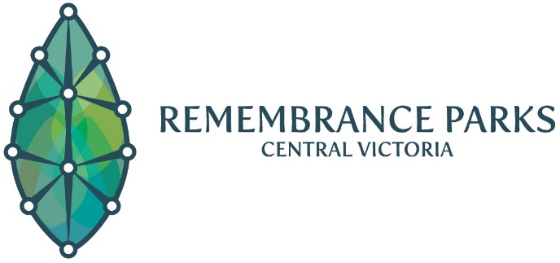
5 Victoria Street, Eaglehawk 3556
PO Box 268, Eaglehawk 3556
ABN: 65 631 351 280
Phone: 1300 266 561
Email: sales@rpcv.com.au
Office Hours:
8:30am – 4:30pm Monday to Friday

Authority to collect Cremated Remains
on behalf of Applicant

Print full name of deceased here:
I, | Print full name of applicant here:
Of, | Insert address of applicant here:
authorise the person(s) listed below, to collect the Cremated Remains of the deceased, on my behalf.
Full Name:
Address:
Signature of applicant: |  | Date:
Applicant photo identification attached:
☐ Drivers Licence ☐ Other ___________________________________
An appointment is required to collect the cremated remains from RPCV’s sales office. The authorised person(s) is required to provide photo identification when collecting the cremated remains. A copy will be kept by RPCV for record purposes.

